Willmott, Glenn (mainly from Linked In)
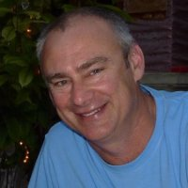

Harvey Agricultural Senior High School 1981 – 1985.
Graduated from Dwellingup/Bunbury Forest cadet course 1987. Forest Officer with Department of CALM/Environment and Conservation January 1988 – September 1996. DEC Senior National Park Ranger January 2001 – October 2009. Project Manager, Capital Works at DEC/Department of Parks and Wildlife. October 2009 – at Margaret River.

